**MARKET BASKET ANALYSIS**

**A Capstone Project Report**

Submitted to

**SAVEETHA INSTITUTE OF MEDICAL AND TECHNICAL SCIENCE**

**CSA1351-Theory of Computation with Recursive Language**

By

**S. Kangana Sri**

**[192210006]**

Supervisor

**DR. C. Anitha**

**Course Code: CSA1351**



**SAVEETHA SCHOOL OF ENGINEERING**

**SAVEETHA INSTITUTE OF MEDICAL AND TECHNICAL SCIENCE**

**June-2024**

**Saveetha School of Engineering**

**ABSTRACT**

The goal of this study is to identify relationships between products that are frequently bought together by using market basket analysis on a retail dataset. Retailers may boost consumer satisfaction, optimize inventory management, and improve marketing efforts by recognizing these tendencies. Preparing the data, running the Apriori algorithm, assessing the outcome, and analyzing the market are all part of the project's steps to determine the business impact.

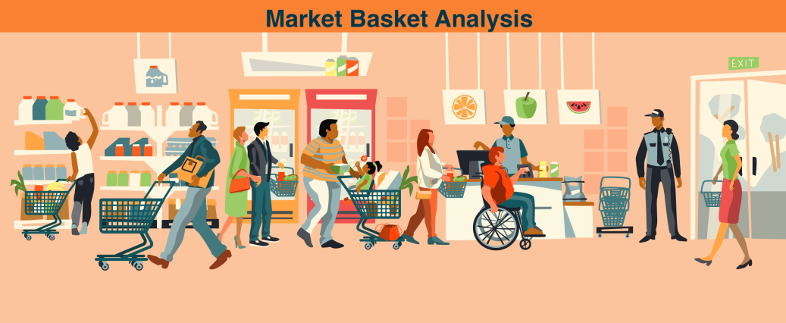

**Problem Statement**

In today's competitive retail landscape, understanding customer behavior and preferences is essential for businesses to remain relevant and profitable. One of the key challenges faced by retailers is the need to uncover meaningful patterns and associations in customer purchasing habits. This includes identifying which products are frequently bought together, understanding the impact of promotions on buying behavior, and optimizing inventory to meet customer demands.

Traditional approaches to merchandising and marketing often lack the precision needed to address these challenges effectively. Without actionable insights into customer behavior, businesses struggle to personalize marketing efforts, create compelling product bundles, and optimize inventory levels. This results in missed opportunities for revenue growth, suboptimal allocation of resources, and diminished customer satisfaction.

**Introduction**

One effective data mining method for identifying links between items bought together in transactions is market basket analysis. Retailers may improve consumer pleasure, optimize inventory, and create focused marketing tactics by comprehending these trends. In order to provide actionable insights for the business, this project will use market basket analysis on a retail dataset to identify frequently occurring item sets and produce association rules.

A crucial data mining method used extensively in the retail and e-commerce industries, market basket analysis reveals trends and connections between products that consumers have bought in tandem. Finding connections between things that are commonly purchased in the same transaction is its main goal, since it provides important insights into customer behavior and purchasing trends. Businesses can optimize a number of facets of their operations, such as product placement, cross-selling tactics, and focused marketing campaigns, by utilizing market basket analysis. Typically, this methodology entails the analysis of transactional data, identification of frequently occurring item sets, and generation of association rules that indicate the probability of a product being purchased in conjunction with another using algorithms such as Apriori or FP-Growth. The advantages are numerous and include better inventory control, better client experiences, and higher revenue through tailored recommendations.

**Market Analysis**

The results of the market basket study are evaluated for possible business impact through market analysis.   
**1. Market research:** Gain knowledge of the retail industry's current consumer patterns and behaviors.   
**2. Competition Analysis:** Examine the tactics of rivals to find weaknesses and openings.   
**3. Implementation Strategy:** Create plans on how to apply the knowledge gained from the market basket study to inventory control and marketing.   
**4. Impact Assessment:** Determine the possible effects on revenue, client contentment, and operational effectiveness.   
**5. Cost-Benefit Analysis:** Compare the anticipated advantages of the initiatives with the expenses of putting them into practice.

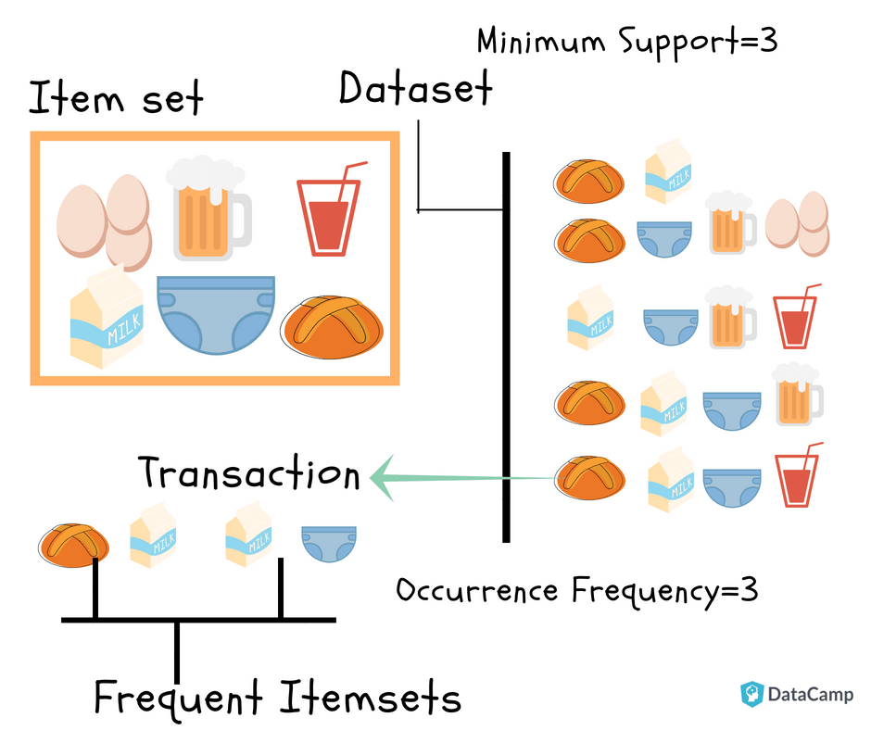

**Data Preprocessing**

Data preprocessing is a critical step to ensure the dataset is clean and suitable for analysis. It involve s the following steps  
**1.** **Data Collection**: Obtain transaction data from the retail system, including transaction ID, item ID, and quantity.  
**2.** **Data Cleaning:** Remove duplicates, handle missing values, and correct any errors in the data.  
**3.** **Data Transformation:** Convert data into a format suitable for market basket analysis, typically a binary matrix where rows represent transactions and columns represent items.  
**4.** **Encoding:** Encode the data to indicate the presence (1) or absence (0) of items in each transaction.  
**5.** **Data Aggregation:** Aggregate data to a level appropriate for analysis, such as consolidating items into categories if necessary.  
**6.** **Aggregation of Data:** If required, combine items into categories and aggregate data to a level suitable for analysis.

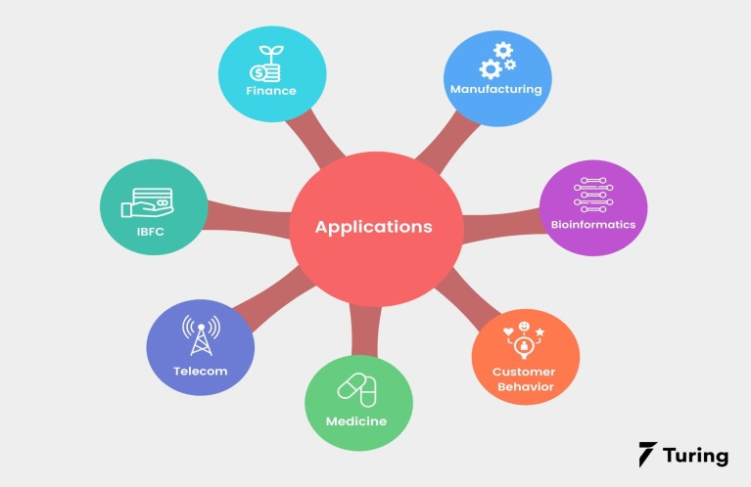

**Feature Extraction**

Feature extraction in Market Basket Analysis involves selecting and transforming transactional data into meaningful features for pattern discovery:

* **Transaction features:** ID, timestamp, total value, item count.
* **Item features:** ID, category, price, quantity.
* **Customer features:** ID, demographics, loyalty status.
* **Derived features:** Item frequency, pair frequency, support, confidence, lift.
* **Aggregated features:** Basket size, value, category frequency, seasonal trends.

**Testing**

Using the Apriori method, testing produces association rules and frequently occurring item sets. The actions consist of:   
**1.** **Method Application:** Based on a given minimum support threshold, locate common item sets using the Apriori method.   
**2.** **Rule Generation:** Using a given minimal confidence threshold, create association rules based on the frequently occurring item sets.   
**3.** **Evaluation:** To make sure the rules offer insightful information, assess those using metrics like lift, confidence, and support.   
**4. Validation:** To make sure the results are robust, validate them using cross-validation or a holdout dataset.

**Analysis and results**  
Utilizing the Apriori method, the study produced association rules and identified frequently occurring item sets. Among the principal conclusions were:  
  
Frequently Found Item sets:  
  
Products like {bread, milk} and {diapers, beer} were found to be often bought in sets.  
Rules of Association Created:  
  
With a 75% confidence level, rules like "If a customer buys bread, they are likely to buy milk" were created.  
To make sure these rules offered insightful information, they were assessed using metrics for lift, confidence, and support.

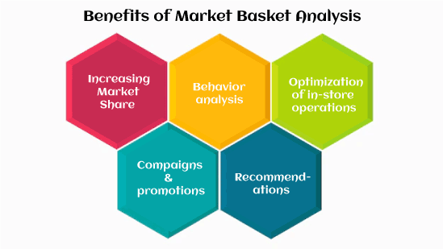

**Conclusion**

The market basket analysis effectively uncovered valuable insights into customer purchasing behavior, revealing frequent item sets and association rules using the Apriori algorithm. These insights enable retailers to enhance marketing strategies, optimize inventory management, and improve customer experiences through targeted promotions and personalized recommendations. Future steps include integrating real-time data, exploring advanced algorithms, conducting segment-specific analysis, expanding to omni-channel data, implementing a feedback loop, and incorporating predictive analytics. Continuously leveraging these insights will help retailers maintain a competitive edge, enhance customer loyalty, and drive sustainable growth.